# MEGA Sensor and Scanner App Instructions

**Sensor Details:**

* Right Foot: Device #7 – MAC address: C8:07:74:90:0C:DF
* Left Foot: Device #8 – MAC address: C1:B1:98:65:E8:E3

The board number (#7 or #8) is shown under the power switch.

The sensor is **OFF** when the selector switch is away from the circuit board. The sensor is **ON** when the selector switch is near the circuit board, as shown below.

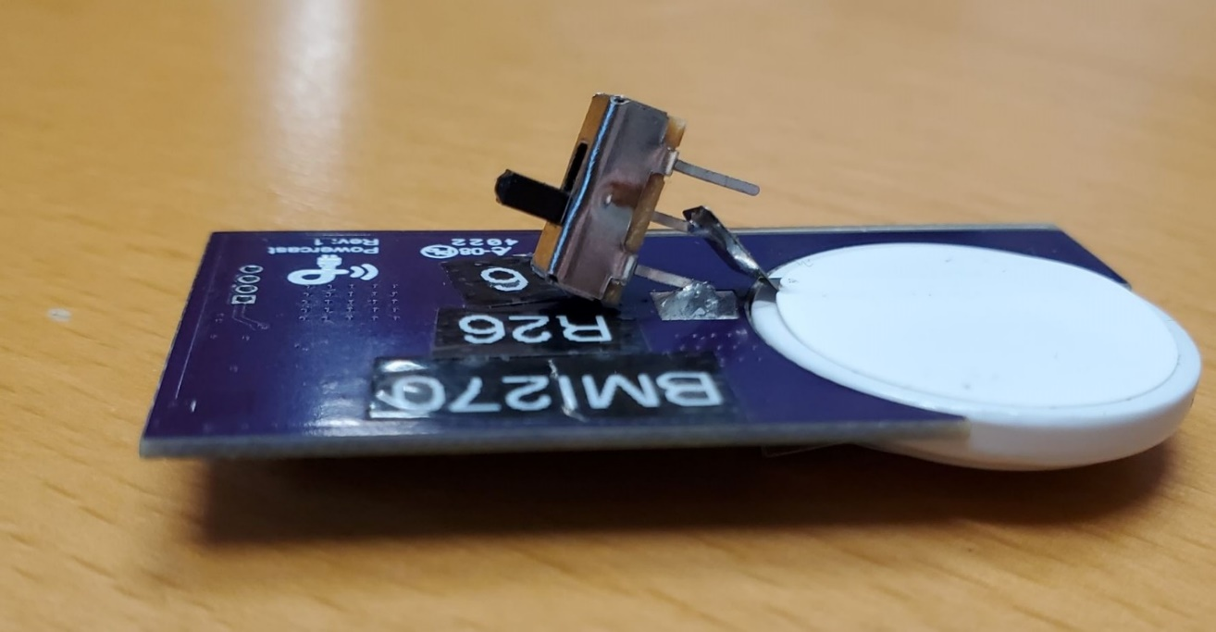

Flip the switch to the ON position. The sensor will immediately begin logging IMU data at the 100 Hz rate.

* Since the switch is controlling power to the device there may be an initial couple second delay as everything is powered on. To avoid any data loss, it is suggested that a 30s-1min buffer is in place from the time of flipping the switch to the beginning of starting the data collection protocol.

The IMU is set to 8G limit for the accelerometer, and 1000 dps for the gyroscope.

The sensor will log data for a 15 minute cycle – it will not collect data for protocols longer than 15min. After 15 minutes, the sensor will switch into ‘BLE Mode’ and begin BLE beaconing. At this point you will be able to open the app, and scan for devices and be able to see the device in its list.

* The device will stay in ‘BLE Mode’ until it is connected to the app., and the files are downloaded.
* If you don’t initially see the devices listed, press the scan button again to ‘refresh’ until they appear.

The app list will show the MAC addresses. Please correlate the MACs with the board numbers and details above (see highlighted text).

Select a sensor from the list to connect to that sensor.

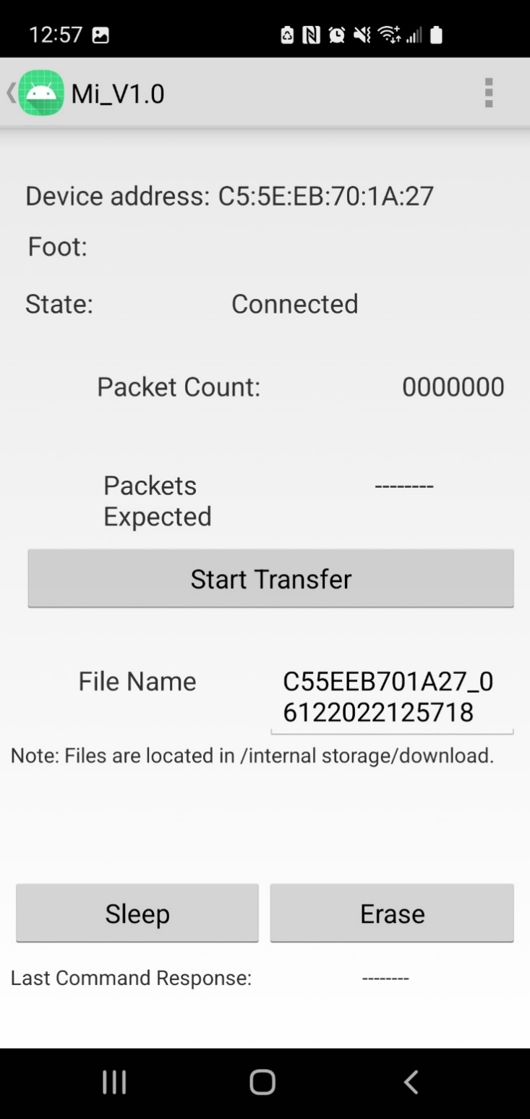



On the Sensor screen, press the “Start Transfer” button to get the data from the sensor. The packet counter will increase until it reaches the expected number of packets. The data will be written to the file on the smartphone or tablet. The file location and name are shown in the app. The data will be stored as a CSV file on the device.

The filename is a concatenation of the MAC address and a timestamp. The filename will change each time a device is connected. The filename can also be edited if desired.

NOTE: The packet counter may stop increasing during the transfer due to connectivity issues, but the app will continuously retry until it gets all the data. No action is required.

The buttons will be grayed out while a transfer is in progress. The device screen will also remain on so as not to interrupt the transfer. However, the back arrow button still works and will disconnect from the sensor if pressed.

* The downloading of the data works at a direct 1:1 ratio, i.e., it takes 15min to collect data within a cycle, it then needs 15min to download all 15min of data.
* Do not exit the transfer screen until all the data is downloaded.
* You CANNOT download data simultaneously from the 2 sensors using only one android device/app. However, if you had 2 android devices both with the app downloaded, you would be able to open up the app on both devices and download a sensor on each device respectively.

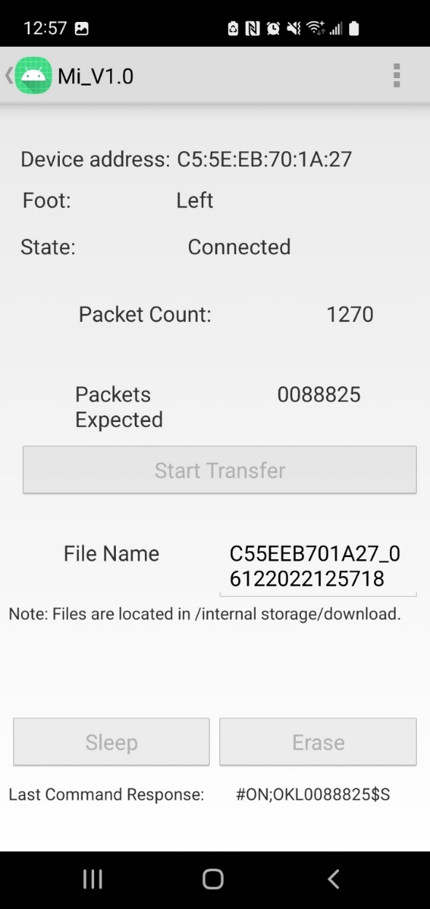

🡨 Back Button



The transfer will complete when the packet count equals the packets expected. The buttons will be available again at this point.

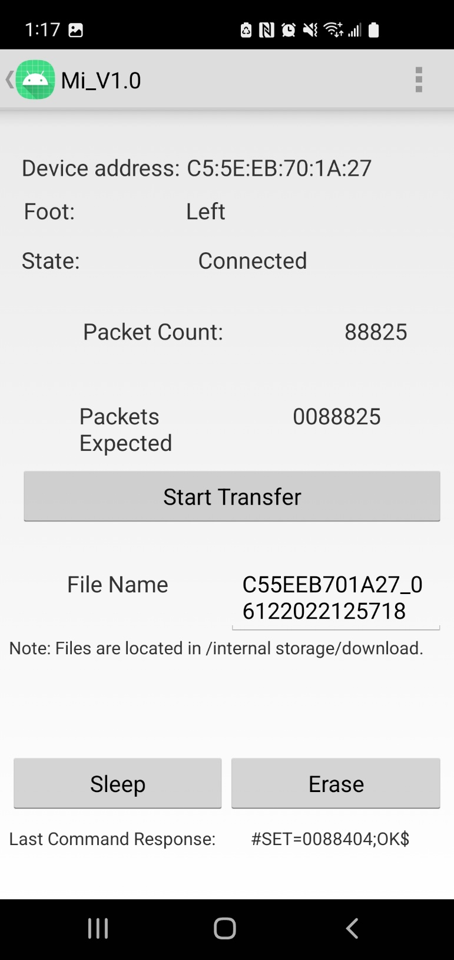

Pressing the “Erase” button will clear the sensor’s onboard memory. After erasing the memory, hit the back arrow or close the app to disconnect from the sensor.

The sensor will then begin logging again. The log will run for 15 minutes again, then BLE beacons will start back up. This cycle can be repeated indefinitely.

When finished with the sensor, place the switch in the OFF position to conserve battery life. Always keep the device OFF when not actively collecting and retrieving data.

Notes:

* The “Erase” button acts as a primer, to work in combination with the “back button” to trigger the switch back to the 15min data collection cycle.
* Meaning, if you hit the “Back” button without having hit the “Erase” button, you will disconnect from that download session, returning to the main “menu” on the app listing the available devices. As a result, the file will have been recorded to your phone with the data up until the point of when you hit the back button.
  + Because you hadn’t hit the “erase” button, when you hit the back button and return to the device list you will be able to then click again on that device and begin a new transfer of the data. Note that it will then record a new file to your phone, and the file name will be adjusted as a result.
* Note: if you are wanting to reset after having downloaded the data, to being the 15min collection cycle, you will either need to turn the device off, or hit the “erase” button followed by the “back button”. Otherwise, it will stay in BLE beaconing mode.

**Data Collection Protocol:**

* Set up the collection scenario/activity, ie. Treadmill, stairs, etc.
* Clip the devices to the shoe.
* Once you’re ready to begin collecting data, switch the devices ON and start a 15min timer.
* Wait 30s-1min prior to initiating testing activity, to provide an initial device ‘start up’ buffer.
* After the buffer, calibrate the start of the activity using a physical trigger to aid with aligning the 2 devices, i.e., Jump.
* Begin collection scenario/activity.
* The devices will continue to collect data until their 15min cycle is complete, use the timer to recognize when this period is coming to an end.
* Once the 15min cycle is up, the device is now ready to be paired via BLE on the app to then begin downloading the data.
* Follow the instructions above.
* Once downloaded, confirm file location within your device.
* Then switch the device OFF, to clear the data cash and reset the timestamp to zero, and conserve battery.
* Repeat.

**Notes:**

Always use the MAC Addresses to properly identify the device and respective data. The app’s foot descriptor (highlighted below) is currently mislabeling which foot the device is collecting from.



When you first open the app found below, it will ask for 3 permissions:

* Location
* Ability to scan nearby devices
* Access files to store data.

These need to be allowed when operating the app.

**The app can be downloaded at the following link:**

<https://drive.google.com/file/d/1NsFZUopPr5GdcjFcNL2dbc5i2pu59QhO/view?usp=share_link>

You'll need an Android device to run the app.